- Load the Iris dataset using Python's sklearn, perform hierarchical clustering with the 'ward' linkage, and plot the resulting dendrogram using scipy's dendrogram() function.
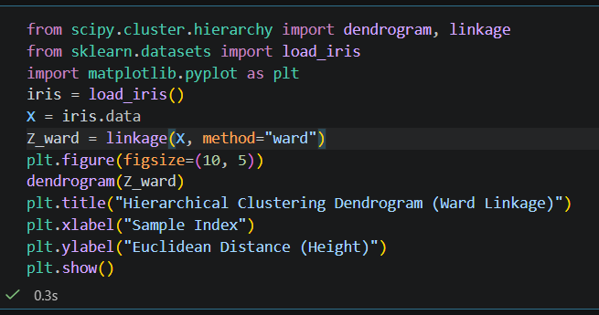
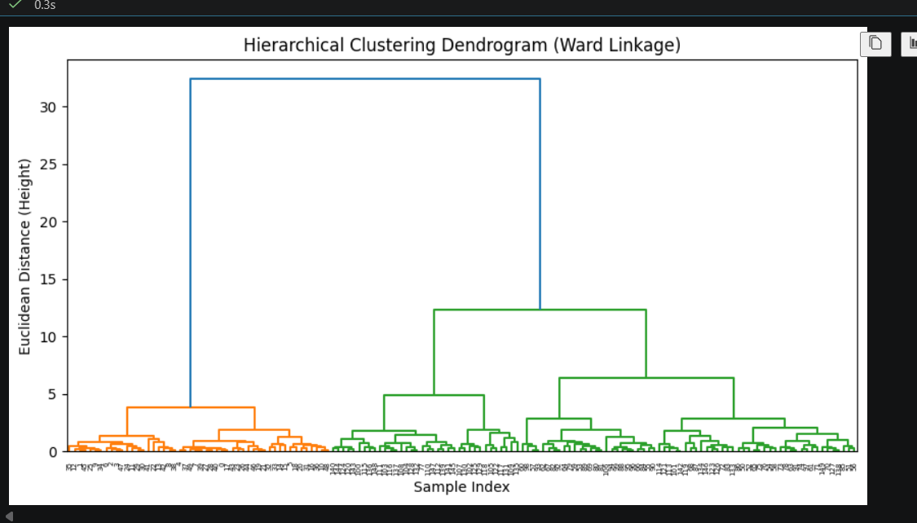
===========================================================================

- Visually inspect the dendrogram you plotted and cut it at a height that results in 3 distinct clusters. Assign each data point to its cluster and print the number of samples in each cluster. Use scipy's fcluster() with the 'criterion' set to 'distance' and your chosen height.
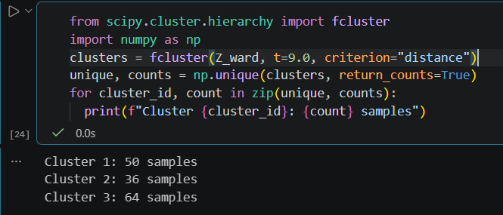

===========================================================================

- Repeat the dendrogram plotting for the same data using 'single' and 'complete' linkage methods, and compare how the cluster shapes and heights differ from 'ward' linkage. Place all three dendrograms side by side for visual comparison.
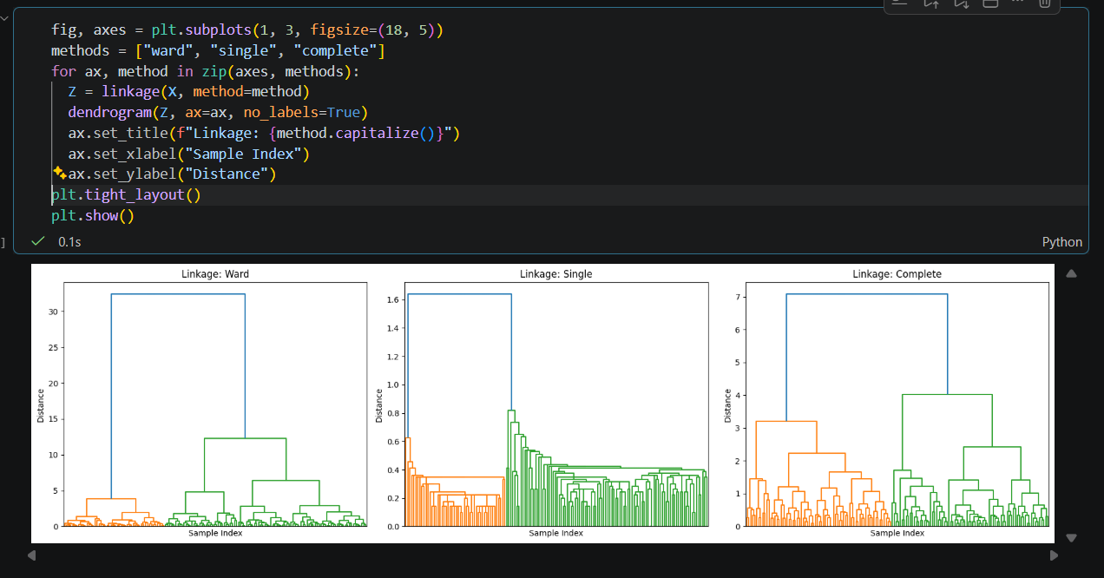

Comparison Observations:
- Ward Linkage: Minimizes variance within clusters, producing balanced, evenly-sized, and compact clusters.
- Single Linkage: Measures the shortest distance between points, resulting in a "chaining effect" where branches string together loosely at very low heights.
- Complete Linkage: Measures maximum distance between clusters, yielding tighter spherical groups but resulting in larger fusion heights than Ward.

- Interpret the dendrogram you created: Write a short explanation (3-4 lines) describing how you can tell which clusters are most similar and which are most different, based on the heights and structure of the branches.

Dendrogram Interpretation
- Most Similar Clusters: Represented by branches that merge together near the bottom of the tree at very short vertical heights, indicating small distances and high similarity between data points.
- Most Different Clusters: Represented by branches that combine near the top of the tree at large vertical heights, showing significant dissimilarity between those groups.
- Tree Structure: The length of the vertical links corresponds directly to the distance between merged clusters; longer vertical lines indicate well-separated, distinct clusters.

